Fish Survey Data Sheet

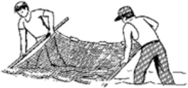

DATE______________________________________________________

LOCATION_____________________________________________________________________

______________________________________________________________________________

Start time___________________ End Time___________________

Moon Stage__________________________

Starting Tidal Stage___________________

Time of Next Tidal Event______________________________________

Weather_______________________________________________________________

Wind Direction & Speed__________________________________

Air Temperature_____________________ Water Temperature________________________

Dissolved Oxygen______________________ Biological Oxygen Demand___________________

Salinity_______________________________ Turbidity__________________________

On additional paper, please record:
- Species of algae (seaweed) thar are present on the beach and in the water.
- Fish & bird bones and common shells (exoskeletons) found on the beach.
- What (if any) are nearby anglers catching.
- Species identified in a seine net (3 to 5 sweeps).
- Please record number of species and sizes (if possible) found in the seine net.

***Please don’t forget to take a plankton sample***

